THE INSILICO LAB
3-Week Virtual Training in CADD
Week 2

Drug-likeness Screening & Molecular Docking

Participant Name  ________Caren Nicole Moreno____________ | Date Submitted  _____________07/16/2026_______________
Cohort / Batch  ___________Cohort 5_______________ | Email Address  _______carenmoreno28@gmail.com__________

📋 Before You Begin
This is Week 2 of The Insilico Lab Training Programme. Ensure you have completed Week 1 (Tasks 1–3) before starting, as this assignment builds directly on those results.

TASK 1 | Drug-likeness Screening

Objective: To demonstrate the ability to perform drug-likeness screening of selected compounds.

▸ Compounds for This Task

🌿  Curcumin | 🌿  Gefitinib | 💊  Kaempferol

▸ Task Description
1 | Go to PubChem (https://pubchem.ncbi.nlm.nih.gov) and search for each compound: Curcumin, Gefitinib, and Kaempferol.
2 | Record the PubChem CID and the canonical SMILES for each compound in the table below.
3 | Download the SDF file for each compound from PubChem (3D Conformer preferred).
4 | Open the SDF files in PyMOL to visualize each compound structure. Take a screenshot for each.
5 | Go to SwissADME (http://www.swissadme.ch) and paste all three SMILES strings into the input field.
6 | Run the analysis and record the Lipinski Rule of Five results for each compound.
7 | Take a screenshot of the SwissADME results page showing the Lipinski scores.

▸ Deliverable 1A — Compound Information Table
Fill in the table below with information from PubChem.

Compound Name | PubChem CID | Canonical SMILES
Curcumin | 969516 | COC1=C(C=CC(=C1)/C=C/C(=O)CC(=O)/C=C/C2=CC(=C(C=C2)O)OC)O
Gefitinib | 123631 | COC1=C(C=C2C(=C1)N=CN=C2NC3=CC(=C(C=C3)F)Cl)OCCCN4CCOCC4
Kaempferol | 5280863 | C1=CC(=CC=C1C2=C(C(=O)C3=C(C=C(C=C3O2)O)O)O)O

▸ Deliverable 1B — Lipinski Rule of Five Screening (SwissADME)
Fill in the Lipinski parameters for each compound from your SwissADME results.

Lipinski Parameter | Limit | Curcumin | Pass? | Gefitinib | Pass? | Kaempferol
Molecular Weight (MW) | ≤ 500 Da | 368.38 | ✓ | 446.90 | ✓ | 286.24
H-Bond Donors (HBD) | ≤ 5 | 2 | ✓ | 1 | ✓ | 4
H-Bond Acceptors (HBA) | ≤ 10 | 6 | ✓ | 1 | ✓ | 6
Lipophilicity (LogP) | ≤ 5 | 2.97 | ✓ | 3.89 | ✓ | 1.20
Drug-likeness (Overall) | All 5 rules |  | Yes |  | Yes

▸ Deliverable 1C — SwissADME Screenshot
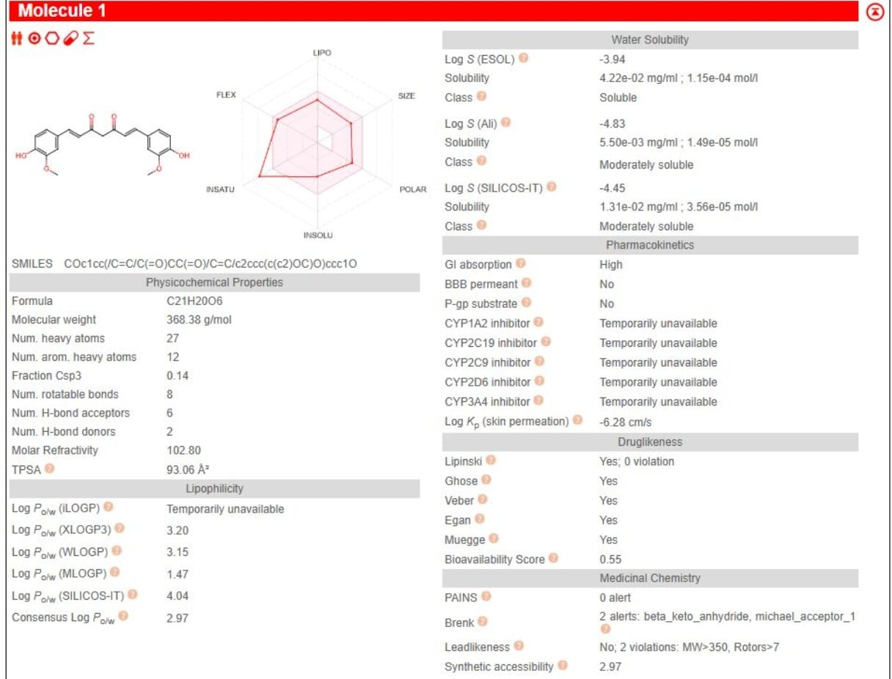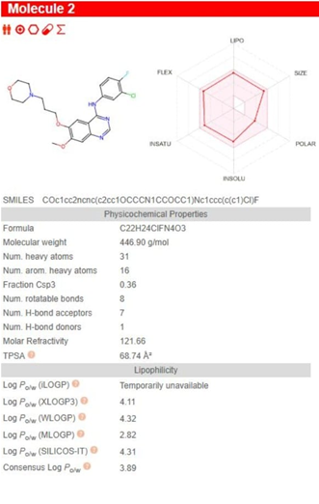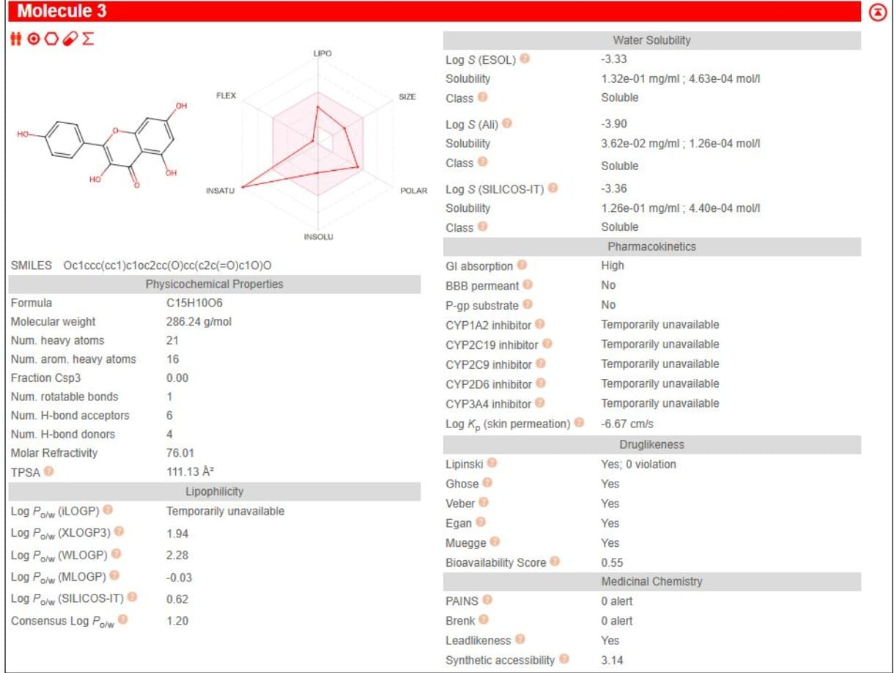
Screenshot 1 — SwissADME Results (Lipinski Scores for All 3 Compounds)

▸ Written Justification
Based on the Lipinski scores, which compound(s) are drug-like? Explain your reasoning. (Write 3–5 sentences below)

All three compounds satisfy the Lipinski Rule of Five with zero violations, indicating favorable oral drug-
likeness. Curcumin and Kaempferol show the lowest lipophilicity (consensus LogP 2.97 and 1.20,
respectively) and high predicted GI absorption, while Gefitinib, despite a slightly higher molecular
weight and LogP (3.89), remains well within Lipinski limits and is additionally predicted to cross the
blood-brain barrier. Kaempferol stands out with the most favorable polarity (TPSA 111.13 Å) and highest aqueous solubility across all three solubility models, whereas Curcumin shows two Brenk structural alerts (a beta-keto anhydride and a Michael acceptor group), which are worth noting for medicinal chemistry, even though they do not affect Lipinski compliance. Overall, all three compounds can be considered drug-like by Lipinski criteria, with Kaempferol showing the cleanest overall physicochemical profile.

TASK 2 | Molecular Docking & Interactions

Objective: To demonstrate the ability to perform Molecular Docking and visualize protein-ligand interactions.

Prerequisites from Week 1
This task uses: (1) the prepared 1U72 protein from Week 1 Task 3, and (2) the binding site residues from Week 1 Task 2. Ensure you have those files ready before starting.

▸ Task Description
1 | Open PyRx and import your prepared protein (1U72prepared.pdb from Week 1 Task 3).
2 | Import the SDF files for all three ligands: Curcumin, Gefitinib, and Kaempferol.
3 | Minimize all ligand structures in PyRx using the energy minimization function.
4 | Define the docking grid box — centre it on the binding site residues identified in Week 1 Task 2.
5 | Run AutoDock Vina for all three compounds against the 1U72 protein.
6 | Record the best docking score (kcal/mol) for each compound from the PyRx results table.
7 | Export the docked poses as PDBQT files.
8 | Open the docked complex in Biovia Discovery Studio (DS). Generate 3D interaction images for each compound.
9 | Use DS to create 2D ligand interaction diagrams for each compound, showing H-bonds, hydrophobic contacts, etc.
10 | Take annotated screenshots of all 3D and 2D interaction images in Discovery Studio.

▸ Deliverable 2A — Docking Scores Table
Fill in the docking results from PyRx below.

Compound | PubChem CID | Best Docking Score (kcal/mol) | Rank
Curcumin | 969516 | -9 | 1
Gefitinib | 123631 | -9.4 | 2
Kaempferol | 5280863 | -8.7 | 3

Tip
More negative docking scores indicate stronger predicted binding affinity. A score more negative than −7.0 kcal/mol is generally considered good.

▸ Deliverable 2B — PyRx Screenshot During Docking
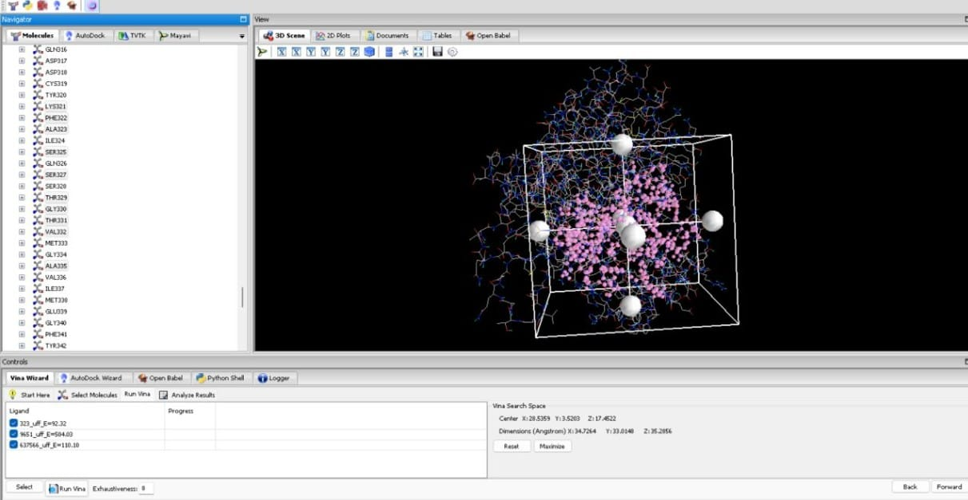
Screenshot 2 — PyRx: Molecular Docking in Progress / Results Panel

▸ Deliverable 2C — Biovia Discovery Studio: 2D Ligand Interaction Diagrams
Note
The 2D diagram maps each interaction type using colour-coded icons. Include all three compounds.

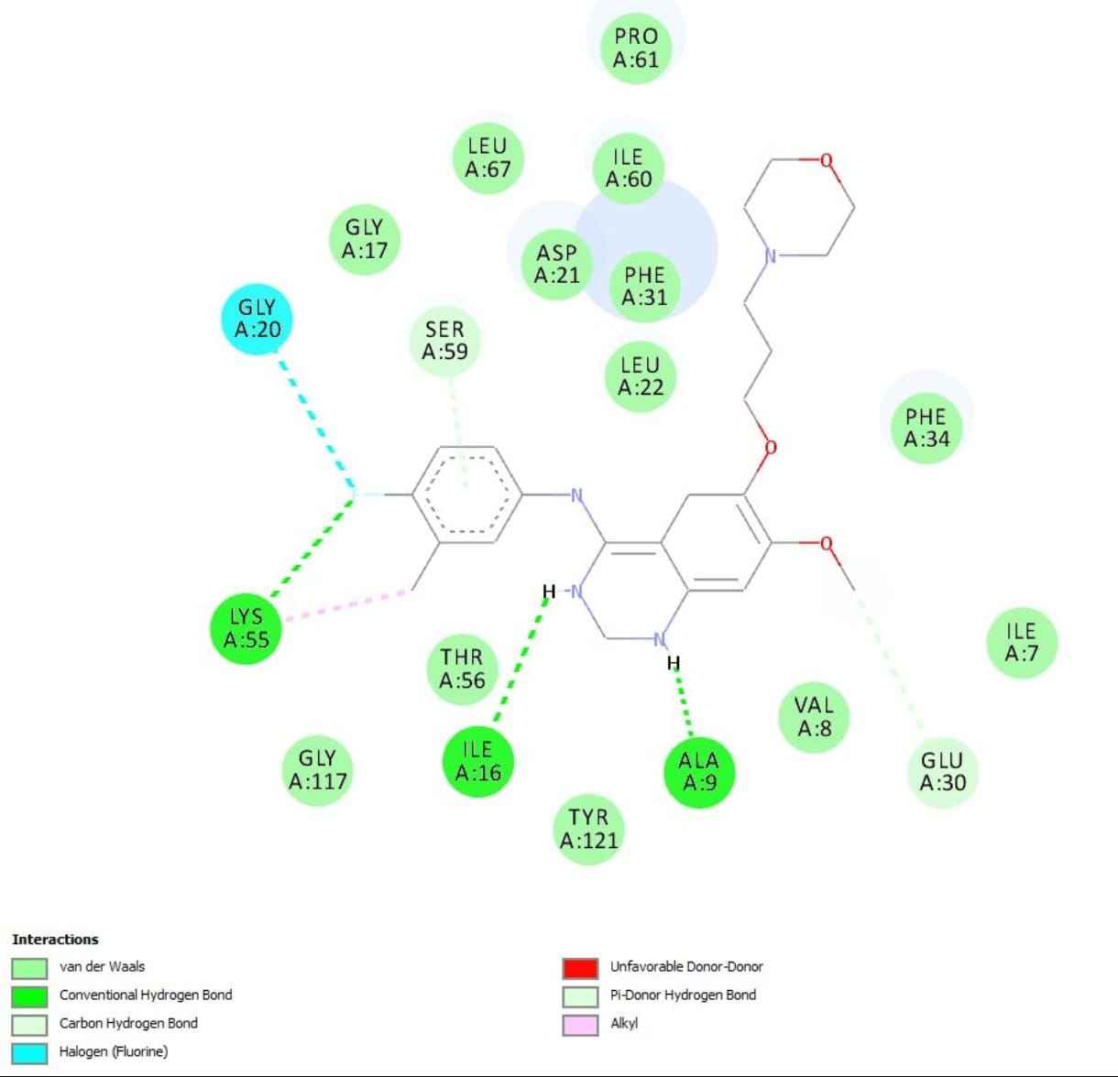
Screenshot 3 — 2D Diagram: Curcumin–1U72 (Discovery Studio)

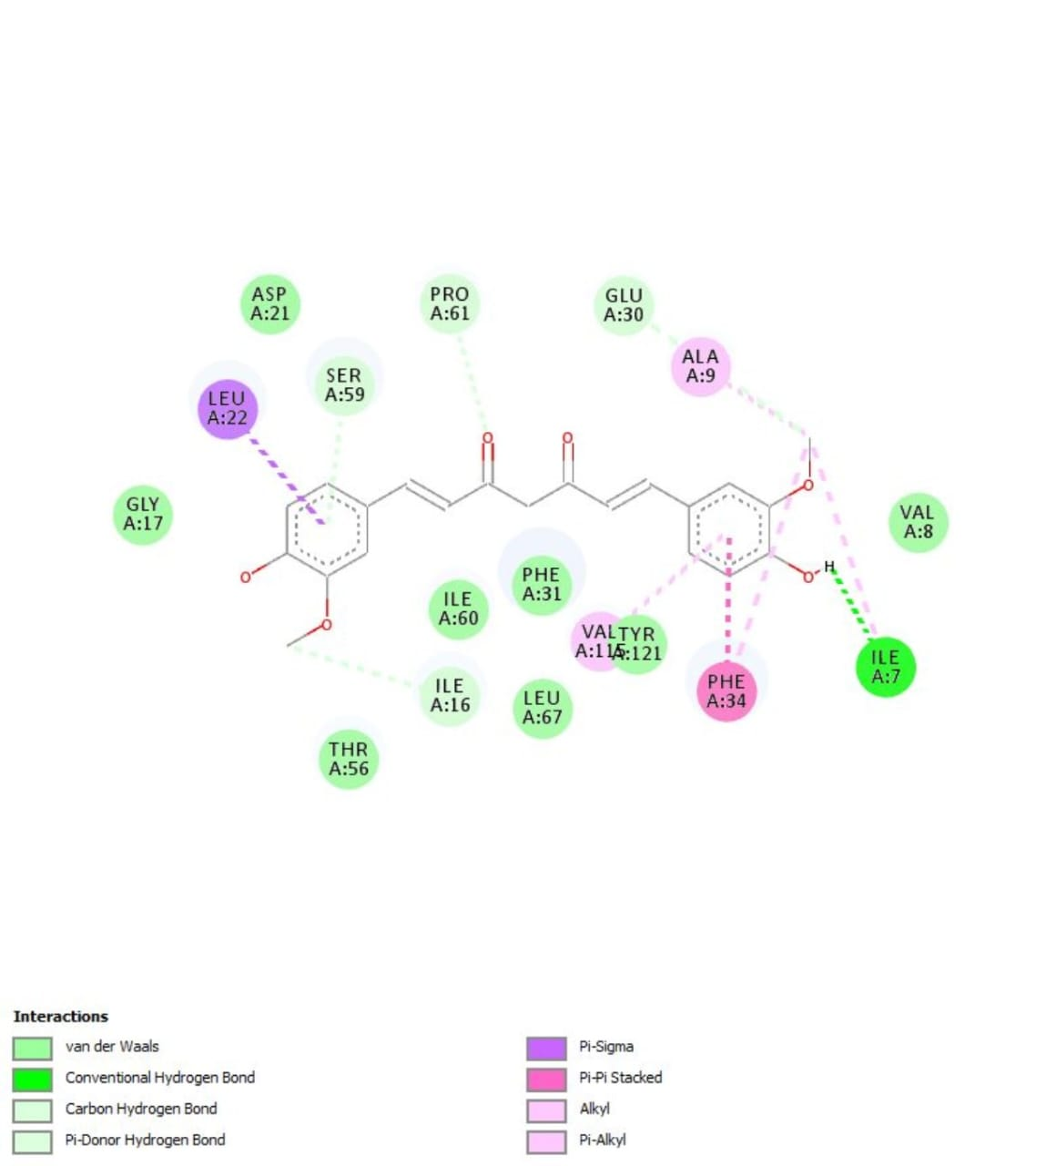
Screenshot 4 — 2D Diagram: Gefitinib–1U72 (Discovery Studio)

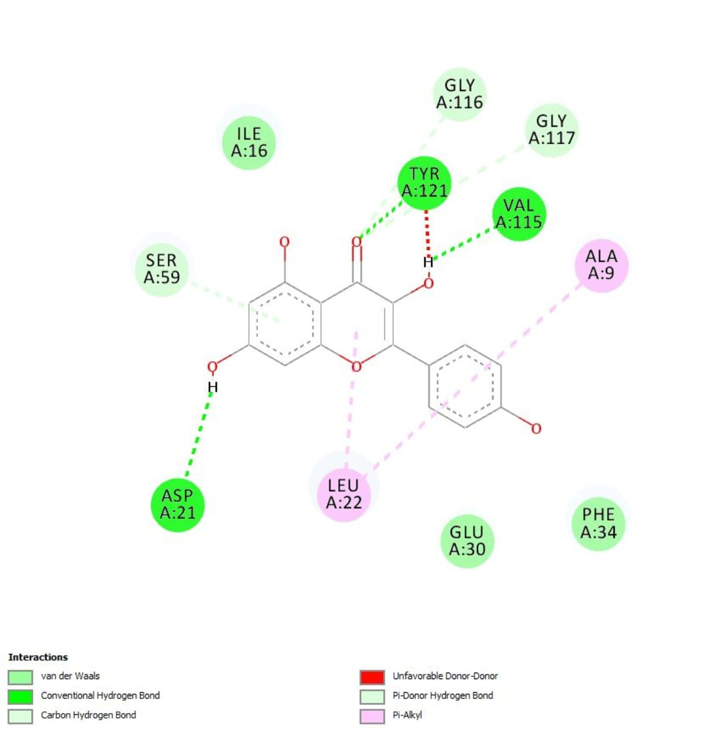
Screenshot 5 — 2D Diagram: Kaempferol –1U72 (Discovery Studio)

▸ Written Justification
Compare the docking scores and molecular interactions of all three compounds. Which compound shows the most promising binding? Use evidence from both the scores and the interaction diagrams to support your answer. (Write 4–6 sentences below)

The docking results show that Gefitinib achieved the strongest predicted binding affinity (-9.4 kcal/mol),
followed closely by Curcumin (-9.0 kcal/mol) and Kaempferol (-8.7 kcal/mol) all three well below the -
7.0 kcal/mol threshold considered favorable. All three compounds docked within the same active site
pocket identified in Week 1, confirming consistency between the predicted binding site and the actual
docked poses. Gefitinib's interaction diagram uniquely shows a halogen bond involving its fluorine
atom, in addition to hydrophobic and van der Waals contacts, which likely contributes to its stronger binding score. Kaempferol's diagram shows extensive Pi-Pi stacking with aromatic residues such as Phe31 and Phe34, consistent with its planar polyphenolic structure, while Curcumin shows a broader network of van der Waals and alkyl contacts but fewer directional interactions. Based on both its top docking score and its additional halogen-bonding interaction, Gefitinib shows the most promising predicted binding profile against 1U72 among the three candidates.

TASK 3 | ADMET Prediction

Objective: To demonstrate the ability to perform ADMET prediction of selected drug candidates using ADMET-AI.

▸ Task Description
1 | Go to ADMET-AI (https://admet.ai.greenstonebio.com/) and select the 'Predict' option.
2 | Enter the SMILES strings for all three compounds: Curcumin, Gefitinib, and Kaempferol.
3 | Run the full ADMET prediction for all three compounds.
4 | From the results, record at least 2 properties for each of the five ADMET categories: Absorption, Distribution, Metabolism, Excretion, and Toxicity.
5 | Take a screenshot of the results page from ADMET-AI showing the ADMET summary for all three compounds.
6 | Download the full ADMET report if available.

What to Report.
You need at least 2 properties per category (ADMET), 10 properties minimum in total per compound. Choose the most pharmacologically relevant ones from the ADMETlab output.
▸ Deliverable 3A — ADMET Properties Tables
Fill in the ADMET values from your ADMET-AI results below.

A | Absorption

Absorption Property | 🌿  Curcumin | 🌿  Gefitinib | 💊  Kaempferol
Oral Bioavailability | 0.46 | 0.94 | 0.36
Human Intestinal Absorption (HIA) | 0.98 | 1.00 | 1.00

D | Distribution

Distribution Property | 🌿  Curcumin | 🌿  Gefitinib | 💊  Kaempferol
Blood-Brain Barrier (BBB) penetration | 0.34 | 0.87 | 0.07
Plasma Protein Binding (PPB) Rate | 91.01 | 94.84 | 90.58

M | Metabolism

Metabolism Property | 🌿  Curcumin | 🌿  Gefitinib | 💊  Kaempferol
CYP1A2 Inhibitor | 0.44 | 0.61 | 0.90
CYP2D6 Substrate | 0.05 | 0.45 | 0.07

E | Excretion

Excretion Property | 🌿  Curcumin | 🌿  Gefitinib | 💊  Kaempferol
Half-life (T1/2) | 0.00 | 52.77 | 8.70
Drug Clearance (Hepatocyte) | 75.97 | 23.79 | 86.24

T | Toxicity

Toxicity Property | 🌿  Curcumin | 🌿  Gefitinib | 💊  Kaempferol
hERG Blocking | 0.53 | 0.94 | 0.45
Mutagenicity | 0.42 | 0.49 | 0.41

▸ Written Justification & Comparison
Compare the ADMET profiles of all three compounds. Which compound has the best overall ADMET profile? Highlight at least 3 specific properties in your comparison and explain what they mean for drug development. (Write 5–7 sentences below)

Overall, all three compounds showed favorable ADMET characteristics, although each presents
different strengths. Gefitinib demonstrated the highest predicted oral bioavailability (0.94) and blood-
brain barrier penetration (0.87), together with the strongest docking affinity, making it the most
promising candidate for this target. Kaempferol exhibited excellent intestinal absorption, the highest
predicted drug clearance, and the lowest BBB penetration, suggesting a favorable safety profile for non-
CNS applications. Curcumin also displayed good absorption and acceptable toxicity predictions but
showed lower oral bioavailability than Gefitinib. These results highlight how ADMET prediction complements molecular docking by identifying compounds with not only strong binding affinity but also favorable pharmacokinetic and safety properties for drug development.

📣 LINKEDIN PORTFOLIO POST
Week 2 — Required Submission

Important
This is ONE single post combining both tasks. Do NOT create separate posts for each task.

▸ What to Include in Your Post

# | Deliverable | Your Response / Submission
1 | Annotated SwissADME screenshot showing drug-likeness / Lipinski results (Task 1) | 
2 | One annotated PyRx screenshot during or after molecular docking (Task 2) | 
3 | One Discovery Studio image highlighting the molecular interaction of the protein with a single ligand (Task 2) | 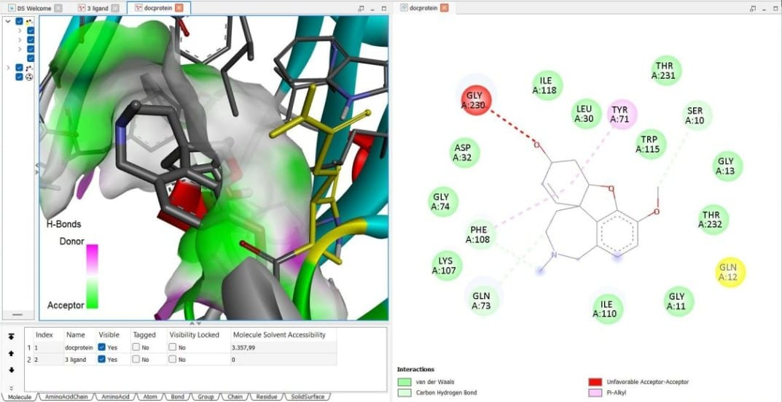
4 | Brief caption for each image explaining what it shows and what you learned | Image 1: SwissADME analysis showed that Curcumin, Gefitinib, and Kaempferol satisfy Lipinski's Rule of Five, indicating favorable drug-like properties for oral administration. Image 2: Molecular docking was performed using AutoDock Vina in PyRx to evaluate the binding affinity of the three compounds against human DHFR. Image 3: The interaction diagram revealed key hydrogen bonds, hydrophobic interactions, and a halogen bond that contribute to the strong predicted binding of Gefitinib to the active site. Image 4: ADMET prediction complemented the docking analysis by providing insights into absorption, distribution, metabolism, excretion, and toxicity, supporting the overall evaluation of potential drug candidates.
5 | Annotated ADMET-AI screenshot showing ADMET prediction results (Task 3) | 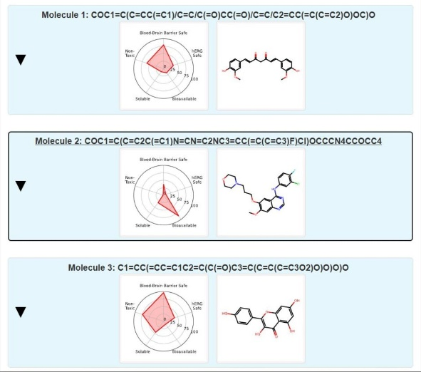

▸ Tagging & Hashtags
Tag: @The Insilico Lab

#CADD | #DrugDiscovery | #ComputationalBiology | #VirtualResearch | #TheInsilicoLab | #Chemoinformatics

End of Week 2 Assignment
Good luck! The Insilico Lab Team

